NISHANT PAREKH – J046

Internet of things – experiment 1

Q.1 – Blinking an LED

Schematic Diagram

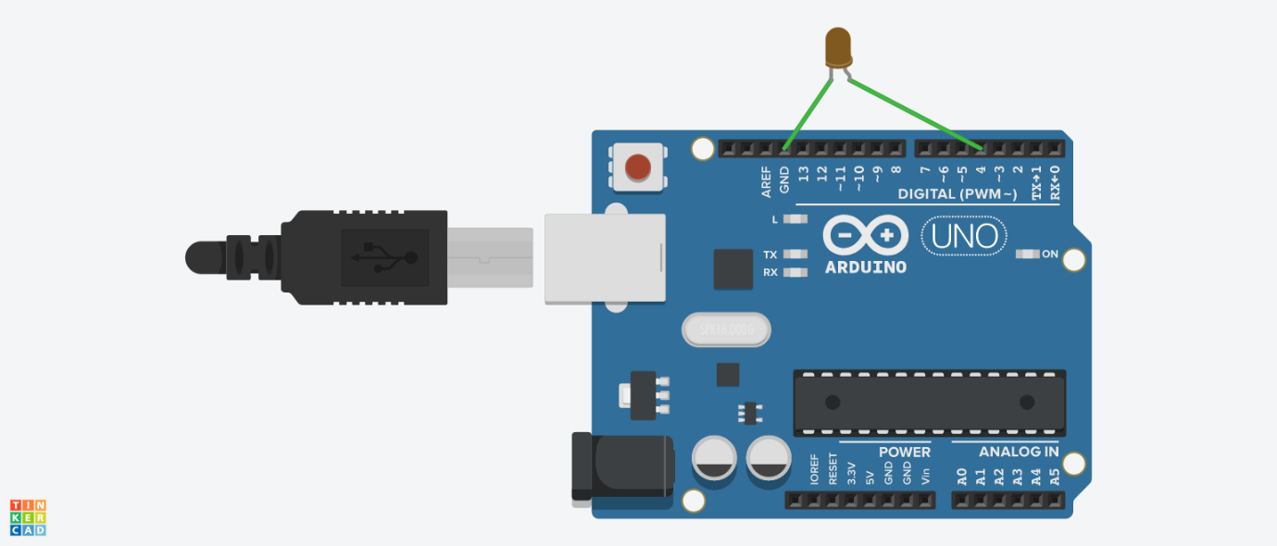

Code

void setup()

{

pinMode(4, OUTPUT);

}

void loop()

{

digitalWrite(4, HIGH);

delay(1000); // Wait for 1000 millisecond(s)

digitalWrite(4, LOW);

delay(1000); // Wait for 1000 millisecond(s)

}

Q.2 – When inbuilt LED is off, external LED is on and when inbuilt LED is on external LED is off.

Schematic Diagram



Code

void setup()

{

pinMode(4, OUTPUT);

pinMode(13, OUTPUT);

}

void loop()

{

digitalWrite(13, HIGH);

digitalWrite(4, LOW);

delay(1000); // Wait for 1000 millisecond(s)

digitalWrite(13, LOW);

digitalWrite(4, HIGH);

delay(1000); // Wait for 1000 millisecond(s)

}

Q.3 – Traffic signal with red, green, yellow LED. Turn on red LED for 2 sec, blink yellow 5 times with 0.5se ON and 0.5 sec OFF then turn on green for 2 secs.

Schematic Diagram

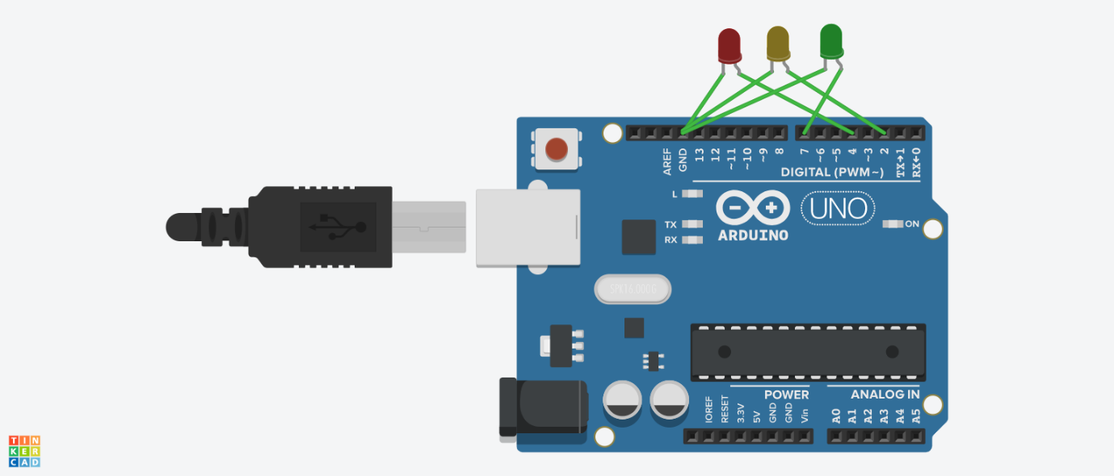

Code

void setup()

{

pinMode(4, OUTPUT);

pinMode(2, OUTPUT);

pinMode(7, OUTPUT);

}

void loop()

{

digitalWrite(4, HIGH);

delay(2000); // Wait for 2000 millisecond(s)

digitalWrite(4, LOW);

digitalWrite(2, HIGH);

delay(500); // Wait for 500 milliseconds

digitalWrite(2, LOW);

delay(500); // Wait for 500 milliseconds

digitalWrite(2, HIGH);

delay(500); // Wait for 500 milliseconds

digitalWrite(2, LOW);

delay(500); // Wait for 500 milliseconds

digitalWrite(2, HIGH);

delay(500); // Wait for 500 milliseconds

digitalWrite(2, LOW);

delay(500); // Wait for 500 milliseconds

digitalWrite(2, HIGH);

delay(500); // Wait for 500 milliseconds

digitalWrite(2, LOW);

delay(500); // Wait for 500 milliseconds

digitalWrite(2, HIGH);

delay(500); // Wait for 500 milliseconds

digitalWrite(2, LOW);

delay(500); // Wait for 500 milliseconds

digitalWrite(7, HIGH);

delay(2000); // Wait for 2000 millisecond(s)

digitalWrite(7, LOW);

}

Q.4 – Create a 5 LED chaser

Schematic Diagram

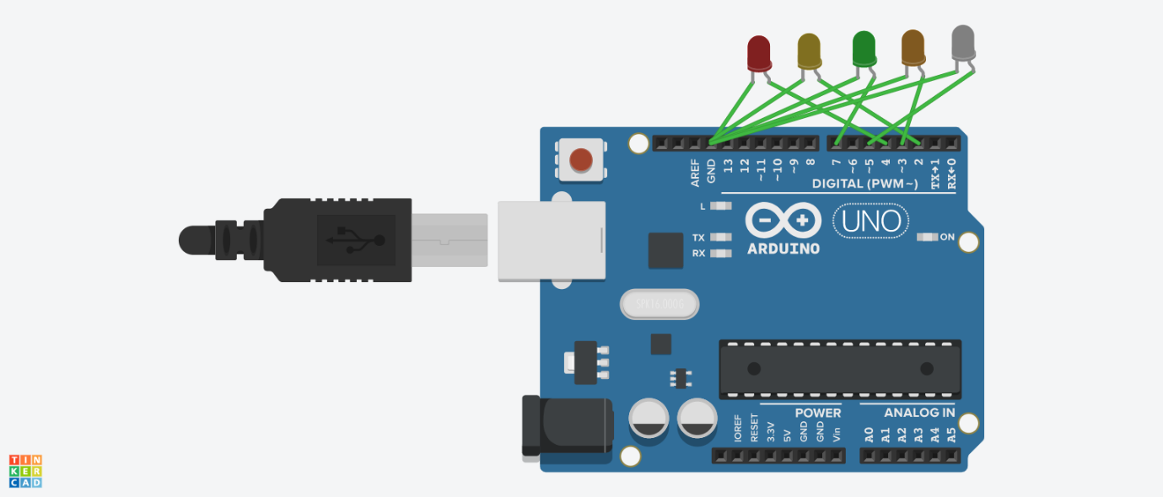

Code

void setup()

{

pinMode(4, OUTPUT);

pinMode(2, OUTPUT);

pinMode(7, OUTPUT);

pinMode(3, OUTPUT);

pinMode(5, OUTPUT);

}

void loop()

{

digitalWrite(4, HIGH);

delay(250); // Wait for 250 milliseconds

digitalWrite(4, LOW);

digitalWrite(2, HIGH);

delay(250); // Wait for 250 milliseconds

digitalWrite(2, LOW);

digitalWrite(7, HIGH);

delay(250); // Wait for 250 milliseconds

digitalWrite(7, LOW);

digitalWrite(3, HIGH);

delay(250); // Wait for 250 milliseconds

digitalWrite(3, LOW);

digitalWrite(5, HIGH);

delay(250); // Wait for 250 milliseconds

digitalWrite(5, LOW);

digitalWrite(3, HIGH);

delay(250); // Wait for 250 milliseconds

digitalWrite(3, LOW);

digitalWrite(7, HIGH);

delay(250); // Wait for 250 milliseconds

digitalWrite(7, LOW);

digitalWrite(2, HIGH);

delay(250); // Wait for 250 milliseconds

digitalWrite(2, LOW);

digitalWrite(4, HIGH);

delay(250); // Wait for 250 milliseconds

digitalWrite(4, LOW);

}